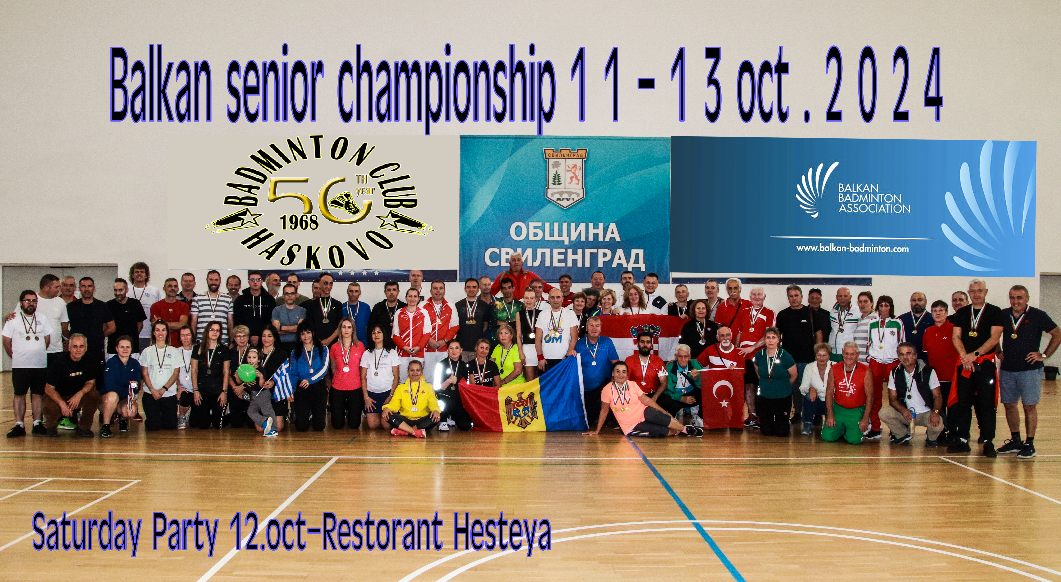BALKAN SENIOR CHAMPIONSHIP
Tournament is part of Balkan Badminton
City SVILENGRAD, BULGARIA
INVITATION
11-13 oct 2024
ORGANIZER: Badminton Club Haskovo
Tel: Peyo Boychinov +359883457921 E-mail:; peyoboychinov@gmail.com
VENUE: Sportna Zala Svilengrad, Svilengrad (Bulgaria)
ADRESS: Sportna Zala Svilengrad,1 Nencho Hristov Str, Svilengrad, Bulgaria
https://goo.gl/maps/iibKcd4qLMvv4Xhk6
DATES:11-13 oct 2024
AGE GROUP: 35+, 40+, 45+, 50+, 55+, 60+, 65+, 70+ and 75+
ENTRIES: Entries must be submitted no later than: 25.SEP 2024, 23:59 BWF HQ Time
Email: Peyoboychinov@gmail.com
ENTRY FEES:Every player can play 3 discipline`s
Discipline - 30 euro per player
Second discipline -10 euro per player
Third discipline-10 euro per player
EVENTS:
Key dates: Entry deadline: 25 SEP 2024
Draws: 02 Oct 2024
Team managers meeting: Sportna Zala Svilengrad, 10 OCT 2024, 19:00h
REFEREE: Slanchezar Zhankov
DEPUTY REFEREE: Petia Georgieva
NUMBER OF COURTS: 6 court
Tournament schedule overview:

Provisional schedule: 11 Oct 09:00 – 20:00
12 Oct 09:00 – 20:00
13 Oct 09:00 – 20:00

SHUTTLECOCKS:We give Plastic shuttle`s Yonex mavis 2000, Every player can use own shuttles(he have to provide for all the match)
PLACE OF ARRIVAL: Sportna Zala Svilengrad,1 Nencho Hristov Str, Svilengrad, Bulgaria or Sofia (International Airport), transportation will be arranged from Airport (Sofia) to city of Svilengrad, will be available for 30 euro per person in one way!
LOCAL TRANSPORT: All official hotels are in walking distance to the venue 200 meter`s .
VISAS: We will provide full visa assistance upon request. You can contact Bulgarian Badminton Federation (Antranik Kasabyan) at badmintonbg@gmail.com by 18 sep 2024 along with passport information.
INSURANCE: Any special medical treatment necessary or hospitalization due to serious illness or injury is at the players or officials, will be on own expenses.
MEDICAL SERVICES: A doctor will be present at the venue during all time of play.

Official e-mails: Peyoboychinov@gmail.com
TEL: +359 883457921 Viber ,WhatsApp

CONTACTS | Peyo Boychinov  Badminton Club Haskovo Organizer)

ACCOMMODATION INFORMATION
HOTEL ROMANTICA****

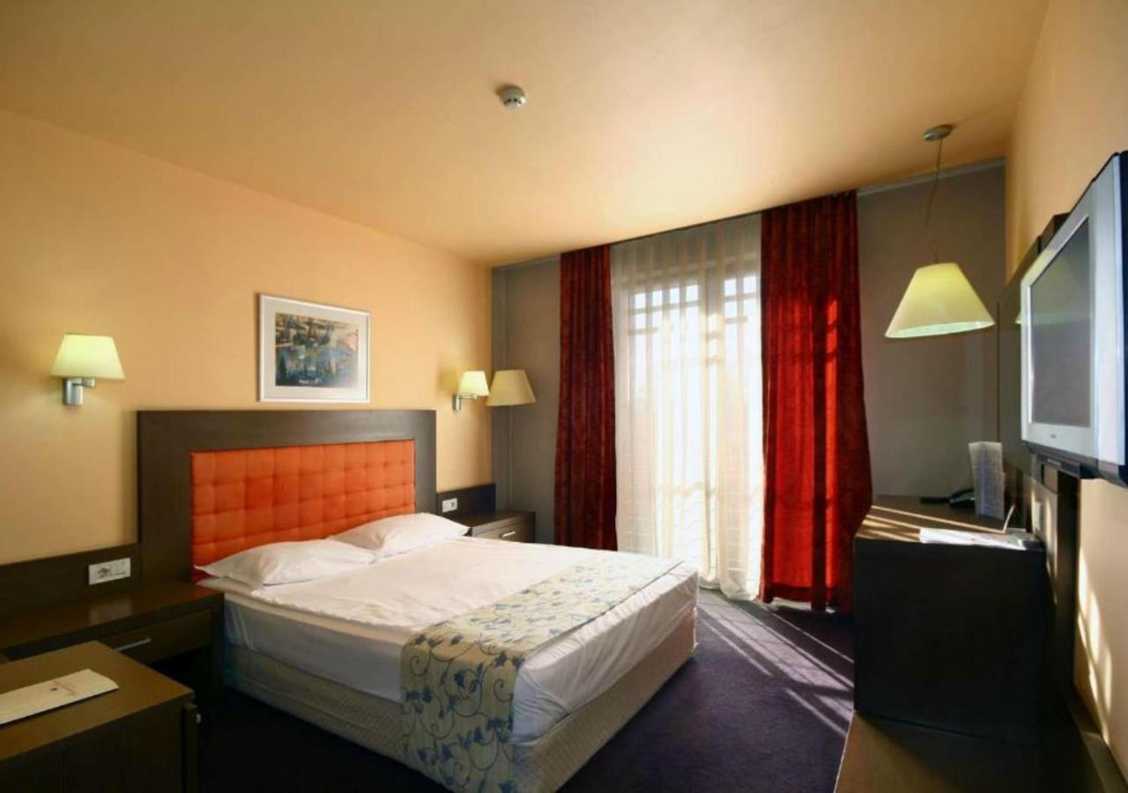
200meters from the sports hall
55 Euro per person (single room) with breakfast +Laundry service
40 Euro per Person (Double room) with breakfast+Laundry service
30 Euro per Person (Triple room) with breakfast+Laundry service
30 Euro per Person (Apart 4 people) with breakfast+Laundry service
Prices are in euro, per person/per night and are inclusive of:
Hotels accommodation, Breakfast, Local tax and VAT
Bookings should be made via e-mail (peyoboychinov@gmail.com) until 01oct 2024
NOTICE: Please be informed that payment of hotel and entry fees must be made to the
ORGANIZER when players arrive in the Hall
CONTACTS:
Peyo Boychinov (Badminton Club HASKOVO Organizer)
E-mail: peyoboychinov@gmail.com
tel: +359 883457921
Peyo Boychinov
Transfer from Sofia airport to city of Svilengrad, will be available for 30 euro per person for one way!
All payments should be made upon arrival in cash!

TOURIST INFORMATION

Svilengrad is a small city close to the Greece and Turkey border.The city is famous with like Small ``Las Vegas`` .You can find a many attraction like a CASINO,Restorant`s,Park area.We put a link below where you can find more information.
Mezek fortress (Neoutzikon)
https://maps.app.goo.gl/EWywsoF49HioUCFJ9

Trakia TOMB
https://maps.app.goo.gl/Eg1FzptMehZ311Y97

NACIONAL PARK KALETO
https://maps.app.goo.gl/shmxw2uJ7nc8yVcG6

Mustapha Pasha Bridge
https://maps.app.goo.gl/Ra3umQEBQTLm9kRq8

